IHCI Week-3 Tutorial Activity

# Rules

* Submit a Google Doc, NOT a PDF or a Google slide.
* Use the default fonts, line spacing, and font size unless specifically required in the assignment.
* After submission, the Google Doc will get automatically locked, so you won't be able to make any changes.
* Standard plagiarism rules apply
* Your submission will not be considered for grading and feedback if you do not follow these guidelines.

**Name:Krishna Shukla**

**Roll No.:2022254**

**HCI Group No.:13**

# Activity

Nowadays, Online grocery stores such as Blinkit, Swiggy Instamart, Zepto, and Dunzo provide a multitude of functionalities. They give you a variety of options such as fruits, vegetables, Dairy, etc. and they also arrive at your doorstep in minutes. In this activity, we want you to design an innovative Online grocery store for your own use. This could be in the form of a mobile application, website, smartwatch application, or some futuristic technology. Your goal is to be innovative and exploratory. We have broken this assignment down into the following steps to make it clearer:

* Think about the interactive product you are designing: what do you want it to do for you? List 3-5 potential users/stakeholders and their context.
* Look around for similar applications and services and make a requirement list of all the interesting, useful, or insightful features as well as usability items you find relevant.
* Sketch out some initial designs for your application. (you can either list them out or sketch them on a piece of paper and upload it)

# Start your activity here!

**Q1)** Think about the interactive product you are designing: what do you want it to do for you? List **3-5 potential users/stakeholders** and their context.

**A1)**

If I had to design an interactive product like this, I would have done the following.

1) *Store pickup item*: I would have given various store pickup options so that people could directly store pick items, and rather than standing in a queue, it would have been a prepaid option

2) *Tracking feature:* While ordering customer should know from which store his item is coming and also be able to.

3) *Delivery options:* Several options are available, including 15-minute delivery, scheduled delivery within a day and three-day scheduled delivery. All delivery options will only be available for some of the items. It would be a store dependent option. Also it would be a prepaid option.

4)*Favorite item:* Keep a list of favorite item that customer love to oder

5) *Potential Customer:* Potential customers could be anyone between 18-55 who can use technology because as store pickup is available, working people could quickly pick up items; they don't need to search various stores for rare items. Also,

non-technology-prone people will use the app with others' help. At last, time is precious to everyone, so everybody would like to use this app as it could save a lot of time

**Q2)** Look around for similar applications and services and make a **requirement list** of all the interesting, useful, or insightful features as well as usability items you find relevant.

**A2)**List of all the interesting, useful, or insightful features are as follows:

1)*Simplicity in design:* Simple design is one of the essential features of any mobile app. Since all human beings need groceries, all complexity in ordering such a basic need should be avoided. Usually, this app has a design that gives quick browsing options and an easy search option for many products.

2)*Accessibility:* These apps provide things at the store price or even cheaper than store rates. Then, while buying, people see if they can get the same item at a lesser price or the same price with much less time at home without any inconvenience. Why not use them

3)*Simple payment:* The apps' integration of various well-known payment gateways ensures that customers can easily select their desired items and place their orders. Online payments are facilitated and integrated to ensure an easy and safe checkout.

**Q3)** Sketch out some **initial designs** for your application. (you can either list them out or sketch them on a piece of paper and upload it)

**A3)**

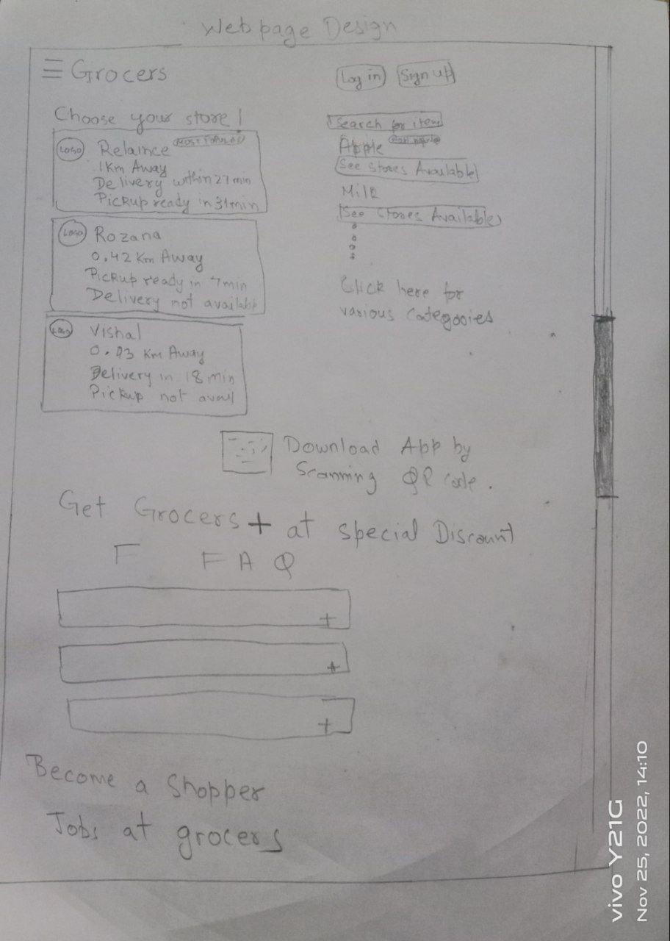

**P.T.O**

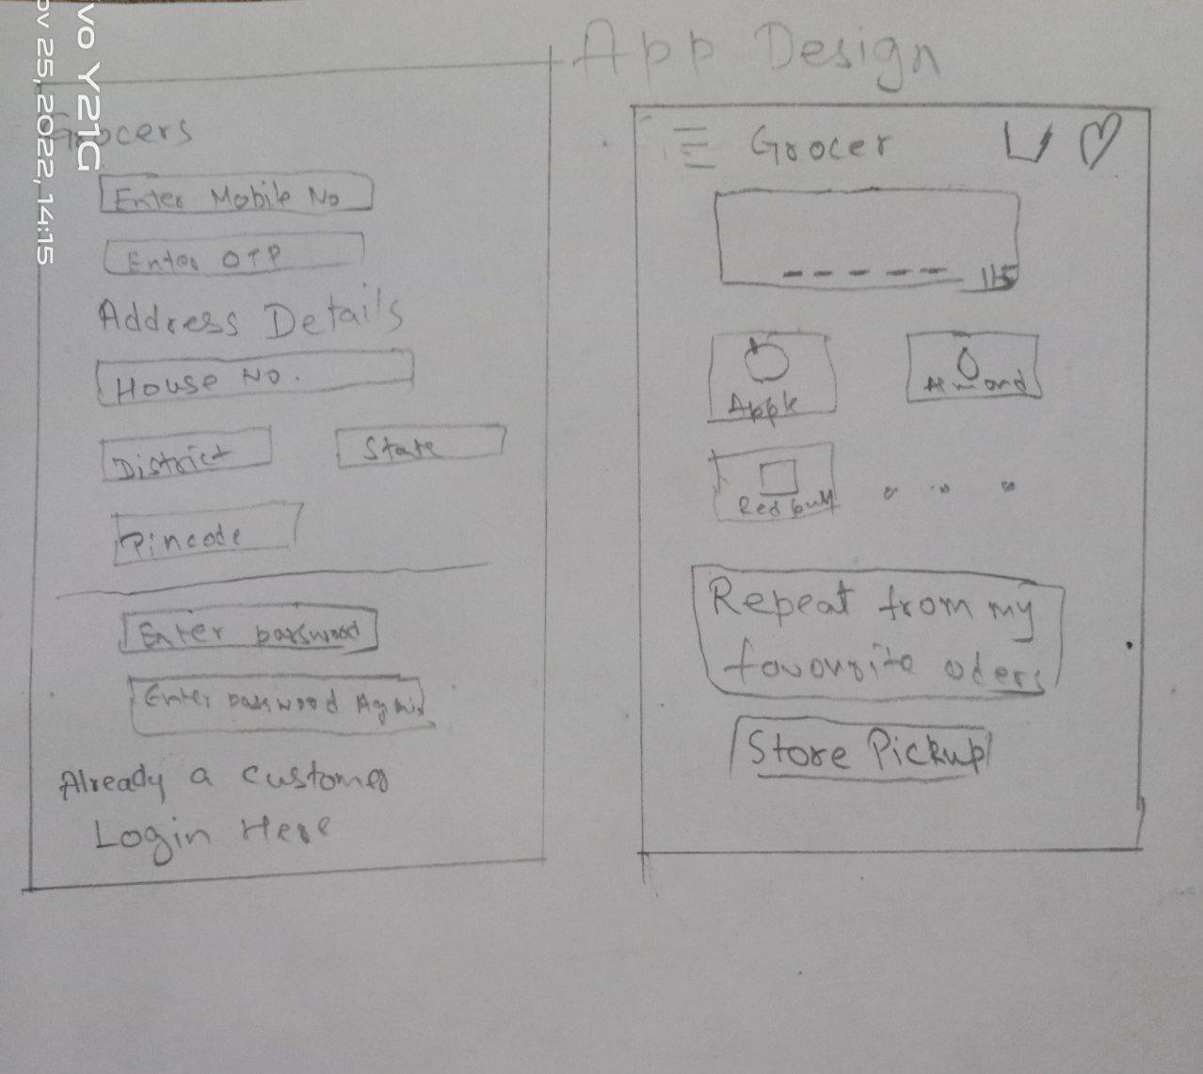

Figma - prototyping

wireframe